Announcement Prior to Distribution:
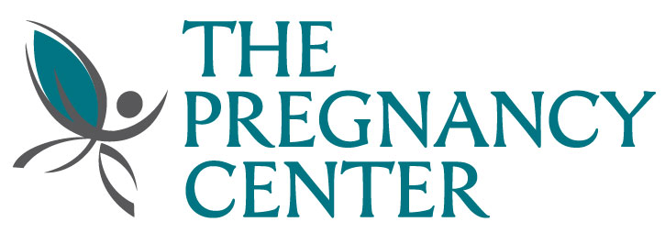

Today we are proud to announce the kickoff for The Pregnancy Center of Sanford, Winter Park, and Mobile’s Annual Baby Bottle Campaign. The Pregnancy Center exists to offer women alternatives to abortion by modeling the love of Jesus Christ through compassionate lay-counseling and the resources to empower her to make a life affirming decision. This year, we are joining forces in making a difference in the kingdom of God by standing in the gap for the unborn. The Baby Bottle Campaign will start on (______________________________) and end on (______________________________). At the end of our worship on (______________________________) we will be distributing baby bottles and asking you to take one or two bottles per family. Fill the bottles with coins, checks and cash or give online at TheDifferenceIsLife.org and make a huge difference in the lives of many infants and their parents. Please direct any questions you may have to (_________________________________________) and watch for additional details about this mission in our church bulletin. All monies collected through the Baby Bottle Campaign will help The Pregnancy Center continue their life-saving work.
Contact Person
Date
Date
Date

------------------------------------------------------------------------------------------------------------------------------------------------------------------------------------------
Announcement for Distribution Sunday:

BEGINNING THIS SUNDAY! At the end of our worship service today, we will be distributing baby bottles for The Pregnancy Center of Sanford, Winter Park, and Mobile’s annual Baby Bottle Campaign. The Pregnancy Centers serve over 200 clients each month. It is through the prayers and provision of local congregations that they are able to continue in this life saving work. They are 100 percent donor supported and receive no monies from the government. Be a part of this ministry by adopting a baby bottle for the next 5 weeks. Put the bottle in a popular place in your home as a reminder to pray for the unborn and the men and women who are facing an unplanned pregnancy. Fill the bottles with coins, cash and checks or give online at TheDifferenceIsLife.org. Return the bottles to the church on (______________________________). Together we can a make a difference in the lives of the unborn.
Date
------------------------------------------------------------------------------------------------------------------------------------------------------------------------------------------

Announcement for Sunday Following Distribution:

THERE ARE BOTTLES STILL AVAILABLE! If you did not get a baby bottle last week, they are still available to take home. At the end of our worship service last week, baby bottles were distributed for The Pregnancy Center of Sanford, Winter Park, and Mobile’s annual baby bottle campaign. The Pregnancy Centers serve 200 clients each month. It is through the prayers and provision of local congregations that they are able to continue in this life saving work. They are 100 percent donor supported and receive no monies from the government. Please take a bottle home today and place it in a popular place in your home as a reminder to pray for the unborn. Fill the bottles with coins, cash and checks or give online at TheDifferenceIsLife.org and make a huge difference. Return the bottles to the church on (______________________________). It's that easy!
Date
------------------------------------------------------------------------------------------------------------------------------------------------------------------------------------------
Announcement Between Distribution and Collection:

Good morning! How's the baby bottle campaign going in your home? This is just a reminder that there are just a few short weeks left in the baby bottle campaign for The Pregnancy Center of Sanford, Winter Park, and Mobile. We hope you are enjoying using this great tool in your families as a reminder to pray for others as well as make an impact in the kingdom of God. Please continue to fill your bottles or give online at TheDifferenceIsLife.org to benefit the ministry of The Pregnancy Centers and remember to turn them in at our church on Sunday, (______________________________).
Date
------------------------------------------------------------------------------------------------------------------------------------------------------------------------------------------

ONE MORE WEEK:
There's just one more week to participate in this once a year baby bottle campaign. Keep filling your baby bottles for The Pregnancy Center of Sanford, Winter Park, and Mobile. Return your filled or empty bottles to the church next Sunday. The collection point will be ____________________________________________________________________________________________________. Every coin adds up. Every prayer makes a difference!
Collection Point Location
------------------------------------------------------------------------------------------------------------------------------------------------------------------------------------------
Collection Sunday Announcement:
Thank you to all who participated in The Pregnancy Center of Sanford, Winter Park, and Mobile’s baby bottle campaign. Please leave your bottles _______________________________________________________ today. These special bottles will be reused by other churches for upcoming campaigns. Forgot your bottle? Just return it next week. Have an empty bottle? Please return that one too! Bringing back an empty bottle is just like donating $1.50 back into the ministry! All support raised through your generosity will be used to minister to infants and their parents. Every coin adds up. Each prayer makes a difference. We rejoice to see how graciously God provides. From the Board, Director, staff and volunteers of The Pregnancy Center of Sanford, Winter Park, and Mobile’s THANK YOU!
Collection Point Location

